SECTION 1 — HERO
SPAN: Atmospheric Water Machine
H1: Air to Water Generators: Generate Water From the Air in Your
Home
Office
Kitchen
Shop
Cabin
Factory
Break Room
PARAGRAPH: No plumbing. No plastic bottles. No problem.
Up to 5.5 gallons a day from the air*
Primary CTA Button: Order Air to Water Generator
Secondary Button: Talk to an Expert
Tertiary Button: Read the Lab Report
$1,495 PRICE · $800 OFF · SHIPS IMMEDIATELY
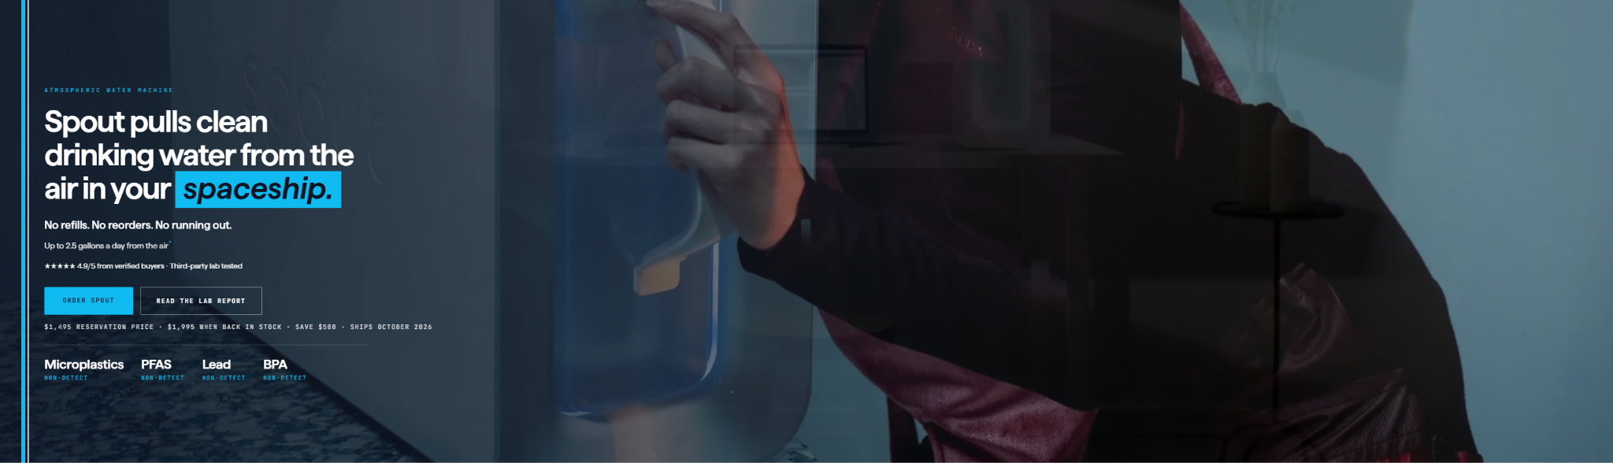

CAROUSEL SLIDER:



SECTION 2 — HOW IT WORKS
SPAN: How It Works
H2: Air In. Water OUT.
Four (4) Boxes:
H3: 01. Air Enters the System
The system pulls in outside air and filters out dust and other particles before collecting moisture.
H3: 02. Moisture Is Condensed
The system cools humid air until the moisture turns into liquid water that can be collected.
H3: 03. Water Is Treated
The collected water goes through filtration and treatment processes designed to improve its quality.
H3: 04. Water Is Stored or Dispensed
The treated water is stored in a tank, dispensed for use, or connected to another water system.
The EPA's assessment of AWGs documents systems using combinations of air filtration, condensation, storage, carbon filtration, sediment filtration, UV treatment, mineralization, and other treatment methods.
CTA Button: Explore the Technology
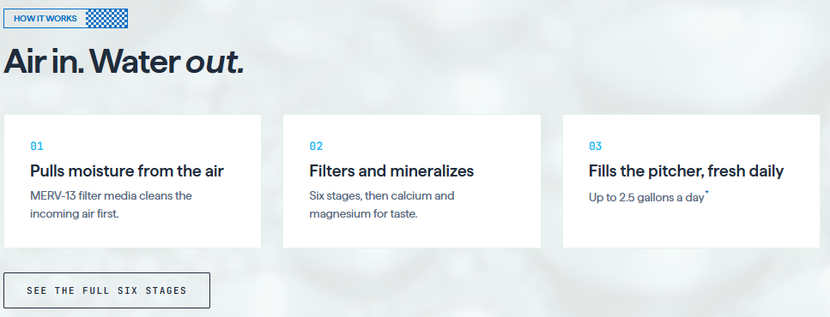

SECTION 3 — WHAT IS AN ATMOSPHERIC WATER GENERATOR?
H2: What Is an Atmospheric Water Generator?
An atmospheric water generator, or AWG, is a system designed to extract water vapor from ambient air and convert it into liquid water. Many systems accomplish this by drawing air into the machine, filtering the incoming air, cooling it to the dew point, collecting condensation, and then treating the collected water through additional filtration or purification processes.
Instead of transporting water from a distant source, atmospheric water generation moves part of the water-production process closer to the place where the water will actually be used.
The technology can range from compact systems designed for drinking water to larger systems capable of supporting commercial, industrial, institutional, and community applications.
EPA research describes condensation-based atmospheric water generation as a technology that pulls moisture from surrounding air, while noting that production depends heavily on available water vapor and temperature.
CTA: Learn How Water From Air Works

SECTION 4 — WHERE AIR TO WATER GENERATORS FIT
SPAN: Where Air to Water Generators Fit
H2: Built for the home first.
Atmospheric water generators offer a new approach to water production by capturing moisture already present in the air. Air to Water Generators helps homes, businesses, organizations, and communities explore scalable water-from-air systems designed to produce water where it is needed.
From individual drinking-water applications to larger commercial and industrial systems, atmospheric water generation can provide an additional source of water without relying exclusively on traditional wells, pipelines, bottled water, or water delivery.
Four (4) Text Boxes:
Residential • Commercial • Emergency • Off-Grid
Box 1:
For Daily Living
Water for the Home
Use it for drinking, meals, coffee, and other everyday needs without relying on bottled water.
Box 2:
For the Workplace
Water for Offices
Provide convenient on-site water while reducing the need for bottled deliveries and disposable containers.
Box 3:
For Added Security
Backup Water Supply
Maintain access to another water source during service interruptions, emergencies, or unexpected disruptions.
Box 4:
For Remote Locations
Water Beyond the Water Line
Produce water in RVs, remote properties, job sites, and other locations where electricity is available.
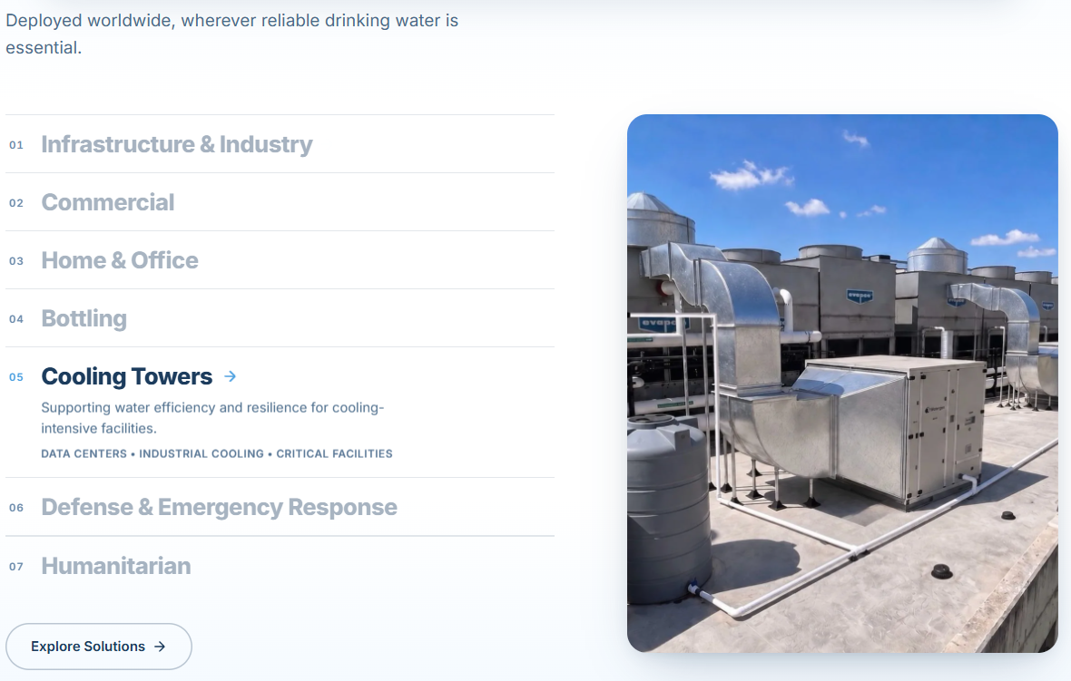

SECTION 5 — WHY ATMOSPHERIC WATER GENERATION?
H2: Why Atmospheric Water Generation?
H3: A Different Way to Think About Where Water Comes From
Most water systems begin with a remote source. Water may travel through wells, treatment plants, pipelines, trucks, bottles, storage tanks, or distribution infrastructure before reaching the people who use it.
Atmospheric water generation introduces another possibility: produce water closer to the point of use by utilizing moisture already present in the surrounding air.
Three (3) Boxes:
H3: Produce Water On-Site
Reduce dependence on transporting every gallon of water from somewhere else.
H3: Build Water Resilience
Add another potential water source where interruptions, shortages, infrastructure limitations, or remote locations make water availability more difficult.
H3: Reduce Bottled Water Dependence
For appropriate applications, on-site generation may help decrease dependence on recurring bottled-water purchases and deliveries.
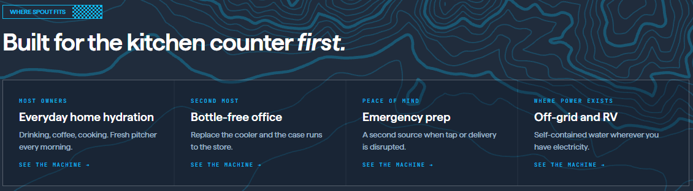

SECTION 5 — DO THE MATH
SPAN: Compare Water Costs
H2: Do The Math
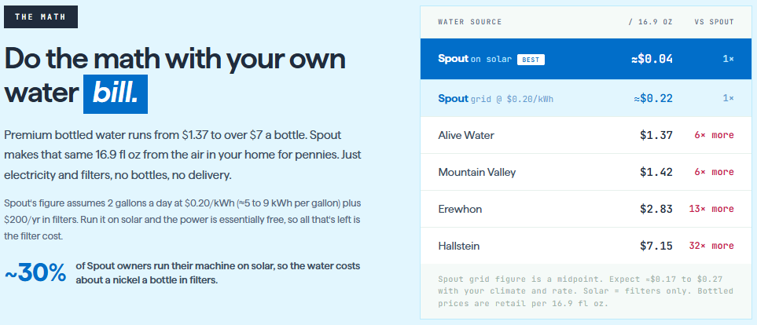

SECTION 6 — AN HONEST COMPARISON
SPAN: Compare and See What’s Best For You
H2: An Honest Comparison
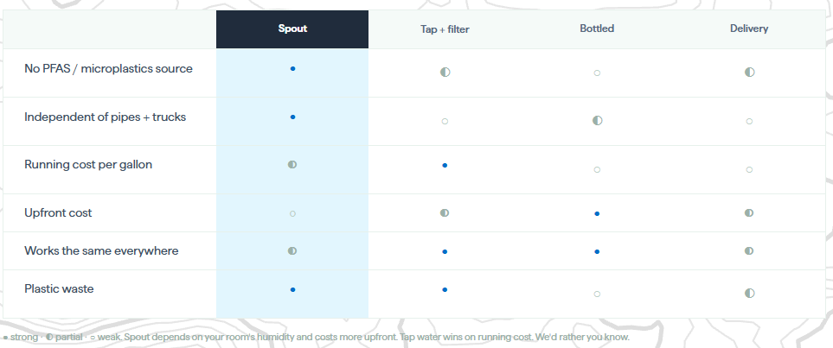

SECTION 6 — FREQUENTLY ASKED QUESTIONS
FAQ: Quick Answers
H2: Frequently Asked Questions
H3: How much water will I get?
Up to 5.5 gal/day depending on your climate. Most owners pour 1 to 3 pitchers.

H3: How loud is it?
You'll hear it in the room, not the next room. Many owners run it overnight.

H3: What does it cost to run?
≈5 to 9 kWh per gallon plus filters. Your rate sets the price; see the math above.

H3: Does it heat the room?
It vents warm air like a large dehumidifier. Summer: run overnight. Winter: free heat.

H3: What are the filters?
Two, swapped every 3 months, under 2 minutes, no tools. $99 per 6-month box.

H3: What if it breaks?
1-year warranty, real phone support: (213) 335-2121. Terms on the product page.

H3: Can I return it?
30-day money-back guarantee from the day it arrives.

H3: What does it taste like?
Alkaline, mineralized. 93% of surveyed owners rate the taste good or excellent.\

SECTION 7 — CALL TO ACTION
H2: Order an Air to Water Generator
$1,495 price, $500 below the $1,995 in-stock price · Ships Immediately · 1-Year Warranty

CTA Button: Order Now

